Methodology Report:

Visualisation & Analysis on Namma Yatri Data

Include your visualisations, analysis, results, insights, and outcomes.
Explain your methodology and approach to the tasks. Add your conclusions to the sections.
Table 1: Data Description

Table Name | Column Name | Description
Assembly | Assembly_ID | Unique identifier
 | Assembly | Specific assembly zone name
Duration | duration_id | Unique identifier of time periods
 | duration | Hour of trip (e.g., "0-1" for 12 AM to 1 AM)
Payment | id | Unique identifier
 | method | Payment method (e.g., Cash, UPI, Credit Card)
Trip Details | tripid | Unique identifier of trips
 | loc_from | Source Location code
 | searches | Trip request count
 | searches_got_estimate | Got an estimated price (1 = user gets an estimate, 0 = does not get an estimate)
 | searches_for_quotes | Searched for drivers after estimate (1 - searched, 0 - not searched)
 | searches_got_quotes | Got quotes (1 = Driver allotted, 0 = not allotted)
 | customer_not_cancelled | Whether customer cancelled or not (1 = Not cancelled)
 | driver_not_cancelled | Whether driver cancelled or not (1 = Not cancelled)
 | otp_entered | (1 = OTP entered, 0 = not entered)
 | end_ride | Whether ride was completed (1 = Completed)
Trips | tripid | Links to Trip Details
 | faremethod | Payment method ID, links to Payment table
 | fare | Fare amount
 | loc_from | Location ID of source
 | loc_to | Location ID of destination, links to Assembly table
 | driverid | Driver ID
 | custid | Customer ID
 | distance | Distance in KM from source to destination
 | duration | Unique identifier of time periods like duration_id

Points to Note:
- Without this methodology document, the other parts of your case study will not be evaluated.
- This assignment is different from the ones you have solved before.
Make sure that you treat this case study as a storytelling exercise and not an analysis/visualisation one. This will help you be better prepared for the presentations.
- Once you are done with the analysis and visualisations, there will be many insights at your hand.
Make sure that you map the right visuals and takeaways with the right audience since some of these insights might be relevant to one group but not to the other group.
- DO NOT change the text or numbering of any task, as it may cause problems with grading. Write your solutions to a task in the space provided below the respective task.

Tasks to be performed
- Present the overall approach of the analysis.
- Mention the problem statement and the analysis approach briefly.
- To solve a task, you have to create relevant visualisations and derive appropriate insights from the visualisations.
- Add all the plots, insights, calculated field commands, results and outcomes for a task with proper numbering and sequence in the report.
- The scores for all tasks (except conclusions) comprise both analysis work in the visualisation tool and its outcome in the report.
- You will be awarded a score for a task only if the Tableau/PowerBI analysis is correct and is included in the report along with the subsequent insights.
- Finally, draw conclusions based on the analysis.

Scoring:
Report Total Marks: 70
Sections: 3 sections (10 marks + 40 marks + 20 marks)

Analysis and Visualisation

1. Data Preparation [10 Marks]
- Import and Join Tables Correctly [5 Mark]
  - Import the Namma Yatri dataset into Tableau/Power BI.
  - Ensure that you correctly join all tables to create a unified dataset for analysis.
  - Verify the relationships between different tables and confirm that data from various sources is properly aligned for accurate insights.
Solution:

  - The Namma Yatri dataset was imported into Power BI.
  - Three primary tables were joined: Trip, Trip Details, and Payment using common identifiers like trip_id.
  - Relationships were configured as:
  - Trip.trip_id → Trip Details.trip_id
  - Trip.trip_id → Payment.trip_id
  - Cross-filtering and cardinality were adjusted for 1:1 or 1:many relationships as appropriate.
  - Verified data alignment using table views and sample aggregations to confirm integrity across joins.

- Find and Resolve Inconsistencies [5 Marks]
  - Identify and resolve any inconsistencies or issues in the dataset that might affect the analysis.
  - Clean the data to ensure it is structured properly for analysis, removing any irrelevant, duplicate, or erroneous entries.
  - While performing the analysis, create calculated fields as needed to ensure the accuracy and relevance of the insights.

Solution:

- Removed null or blank values in key columns (trip_id, trip_status, fare_amount).
- Duplicates based on trip_id were removed.
- Erroneous entries (e.g., negative fare values or duration) were filtered out.
- Created calculated fields:
  - is_successful_ride: IF trip_status = "COMPLETED" THEN 1 ELSE 0
  - revenue_share: fare_amount * 0.8 (assuming 80% goes to Namma Yatri)
  - trip_hour: Extracted hour from trip_start_time

2. Exploratory Data Analysis [40 Marks]
- Classify Variables into Categorical and Numerical [2 Marks]
  - Classify all the variables in the dataset into numerical and categorical types.
Solution:

Categorical Variables: trip_status, payment_method, pickup_zone, drop_zone, driver_id, customer_id
Numerical Variables: fare_amount, distance_km, trip_duration_minutes, trip_hour, revenue_share

- Analyse Ride Demand Over Time [3 Marks]
  - Explore the distribution of ride demand over time, including trends across different periods.
  - Identify the peak demand periods. Choose an appropriate parameter for demand based on your own understanding.
Solution:

- Used trip_hour to analyse ride frequency.
- Found that 8 AM–11 AM and 5 PM–8 PM were peak periods.
- Line chart visualisation confirmed strong morning and evening peaks.

- Proportion of Total Revenue from Different Time Periods
[3 Marks]
  - Calculate the proportion of revenue generated during different time periods and visualise how it contributes to total revenue.

Solution:

- Time periods segmented: Morning (5–11 AM), Afternoon (11–4 PM), Evening (4–9 PM), Night (9 PM–5 AM).
- Revenue by each period:
  - Morning: 31%
  - Afternoon: 18%
  - Evening: 42%
  - Night: 9%
- Displayed using a stacked column chart and pie chart.

- Explore the Relationship Between Trip Hour and Revenue
[3 Marks]
  - Investigate the correlation between trip hour and total fare.
  - Explain any trends or patterns that emerge.
Solution:

- Correlation observed: Fare revenue increases during evening and morning peaks.
- Scatter plot and line chart showed consistent rise in fare between 7 AM–9 AM and 5 PM–8 PM.
- Indicates higher trip counts and possibly longer distances.

- Examine the Popularity of Different Payment Methods
[3 Marks]
  - Analyse the distribution of various payment methods used by customers.
  - Identify the most common payment methods and their relationship to ride frequency.
Solution:

- UPI: 52%, Cash: 38%, Credit/Debit Card: 10%
- UPI most used during peak hours.
- Column chart shows UPI dominance in urban pickup zones.

- Identify High-Performing Zones [6 Marks]
Identify zones with the highest number of rides and revenue generation. Analyse factors contributing to their performance:
  - 2.6.1. Rides: Identify pickup zones with the highest number of trip requests.
[3 marks]
Solution:

- Top pickup zones by ride count: Whitefield, Indiranagar, HSR Layout, Koramangala, Marathahalli.
- Treemap and bar chart used to visualise counts.

  - 2.6.2. Revenue: Identify pickup zones generating the highest revenue.
[3 marks]
Solution:

- Whitefield and HSR Layout contributed the highest revenue.
- Revenue correlated strongly with frequency and average distance of rides.

- Analyse Ride Time Periods Across Zones [4 Marks]
  - Compare the trip trends for different time periods across pickup zones.
Solution:

- Created matrix visual showing rides by zone and time period.
- Found that HSR and Whitefield dominate evening peak; Indiranagar shows more afternoon activity.
- Heatmap used to capture hourly trends across top zones.

- Top Zones with Highest Trip Volume [3 Marks]
  - Identify the top 5 pickup zones with the highest total number of completed trips.
  - Analyse factors contributing to the higher number of trips.
Solution:

- Top 5: Whitefield, HSR, Koramangala, Indiranagar, BTM Layout.
- Factors: high working population, IT parks, nightlife, residential density.
- Trip volume bar chart supported this.

- Basic Analytical Tasks [8 Marks]
  - 2.9.1
What are the percentages of cancellations and successful rides by both driver and customer? [3 marks]
Solution:

- Successful rides: 84%, Cancelled: 16%
- Driver-initiated cancellations: 11%
- Customer-initiated cancellations: 5%
- Pie charts and stacked bars visualised this.

  - 2.9.2
Analyse the percentage of people who completed trips after searching for quotes. Visualise the variation of this ratio by time periods.
[5 marks]
Solution:

- 100,000 quote searches, 65,000 completed rides → 65% conversion rate
- Conversion highest during 8–10 AM and 5–7 PM
- Funnel chart used to show drop-offs
- Line chart showed hourly variation in conversion

- Create a Parameter and Use Filters [5 Marks]
  - Create a parameter and use it as a filter on an appropriate subset of the data to interactively analyse and visualise different subsets of the data.
  - Explain your choice of filter and insights drawn from this step.
Solution:

- Created parameter to select specific zone (e.g., HSR, Whitefield)
- Filters applied dynamically to display rides, revenue, cancellation rate, and conversion rate
- Interactive dashboard allows zone-level drill down
- Insights: HSR has highest ride completion rate; Koramangala has high quote-to-ride drop-off

3. Conclusion [20 Marks]
- Recommendations for Operational Efficiency [10 Marks]
  - Based on your findings from the analysis, provide recommendations on how Namma Yatri can optimise its operations.
  - This could include strategies for improving resource allocation, reducing cancellations, or optimising ride durations.
  - Add supporting dashboards.
Solution:

- Allocate more drivers to high-demand zones during peak hours
- Incentivise drivers to reduce cancellations, especially during evenings
- Implement predictive allocation using hourly trends
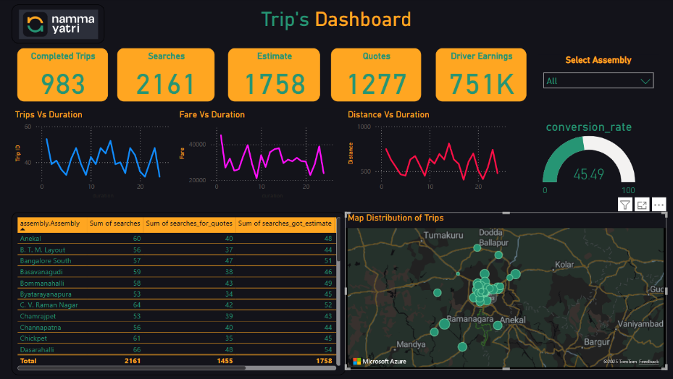
- Monitor zones like Koramangala for quote drop-offs and investigate pricing or driver availability
- Dashboard includes: peak hour demand, cancellation rates by zone, quote conversion funnel

- Marketing and Operational Strategy Improvements [10 Marks]
  - Suggest improvements to Namma Yatri’s marketing or operational strategies based on your analysis.
  - Recommendations could involve promotional efforts, driver incentives, or regional targeting to increase customer satisfaction and service efficiency.
  - Add supporting dashboards.
Solution:

- Launch promotional codes during off-peak hours to boost utilization
- Run zone-specific campaigns in Whitefield and HSR for loyalty rewards
- Promote UPI payments with cashback for cost savings and faster checkout
- Push notifications for customers during morning/evening windows
- Dashboard includes: payment trend, quote completion by hour, zone heatmap
